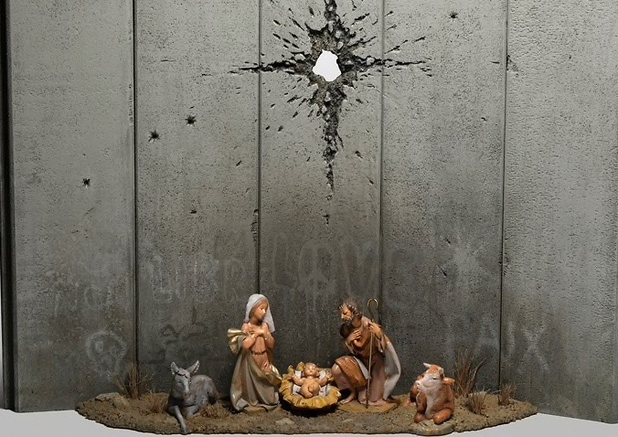
Scar of Bethlehem 2019
Chris McDonnell
Banksy is a western Graffiti street artist about who little is known, apart from his stunning work. Every so often a new piece appears. His latest offering – his take on a nativity scene – was unveiled before Christmas at a hotel in Bethlehem.

The Scar of Bethlehem features a nativity scene with Mary and Joseph and the baby Jesus, but instead of a star hanging in the night sky over the crib there is what appears to be a large bullet hole piercing an imposing grey wall.

The piece has appeared in the Walled Off Hotel, which Banksy helped set up and overlooks the border wall in the divided city. Opened two years ago, the hotel is billed as having “the worst view of any hotel in the world” “Love” and “Peace” are respectively tagged in English and French on the installation’s concrete blocks, while three large wrapped presents are in front of the scene.

Street art is a powerful expression of political expression around the world. The colourful favelas in Rio, the poor quarters of the city, express the feelings, struggles and lives of the people.

Closer to home, the gable-end images that can still be seen in the towns of Northern Ireland are a poignant reminder of the thirty years of conflict that are so often simply referred to as ‘the Troubles’. The icons of green and orange remain. Pictures of the Berlin Wall before its removal in 1989, with the collapse of the Iron Curtain, show the side facing West Berlin covered with a wide variety of colour-sprayed images and words rejecting the division of the city.

The wall that divides the city of Bethlehem-whose name in Hebrew בֵּית לֶחֶם Bet Leḥem, meaning "House of Bread"-is part of the wall that now separates the state of Israel from the Palestinian peoples.

Walls divide peoples, keep us apart from those who threaten security. They also divide families, those who live or work on one side or the other. Bansky has shown us a traditional crib scene that is in stark relief to the image of the pierced wall, where the star that hovered over the city, the star that guided the Wise Men has become the scar of a shell hole.

As we begin a New Year so may we see the removal of the many walls, both real and figurative, that still divide us.

END

