***Zuhlsdorf demythologized by Francis***

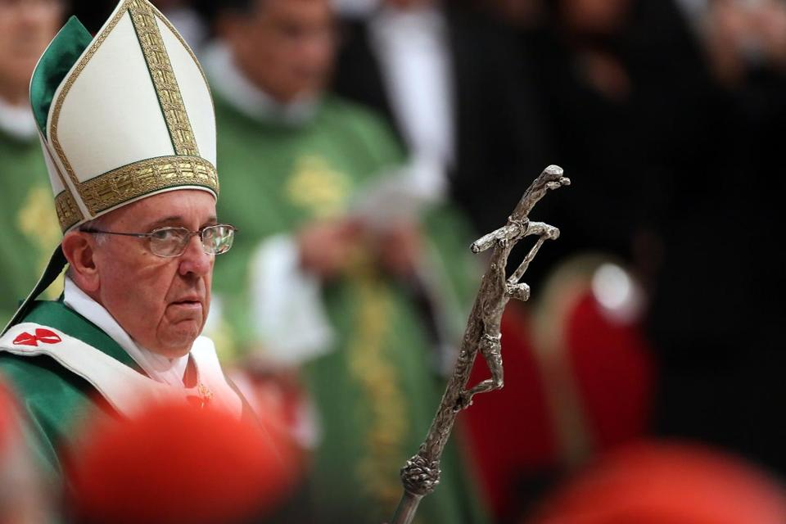

is closely scrutinising

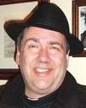

***Zuhlsdorf – you can’t make this stuff up – Part II***

John Todd Zuhlsdorf, a conservative American career Restorationist and blogger, has had a very bad year. It has been perhaps the worst period in his entire life and it is not getting any better. Firstly, he was personally devastated by Benedict XVI’s abdication. Secondly, his shock and depression were soon compounded and transformed by paroxysms of resentment, anger and indignation. The situation was not made easier with the election of Jorge Bergolio an Argentinian Jesuit. Zuhlsdorf, from day one of his Papacy, has not ceased in his private campaign of toxic subversive and smouldering invective. Pope Francis has symbolically brought to an end the *Golden Age* of ecclesiastical Conservatism which marked the JP II/Benedict years. Zuhlsdorf has regressed into a mood of sulky teenage reactive bad grace. Ironically though, the more he targets Francis with his infantile passive aggression, the deeper he digs his own grave with his teeth. Others can see it happening. Zuhlsdorf, apparently, cannot.

***Zuhlsdorf Inc.***

Over a decade ago, Zuhlsdorf cleverly identified a niche market in the Traditionalistist/Restorationist sub-culture. Energetically grasping the opportunity, he quickly transformed himself into a successful entrepreneur. He has been dining sumptuously off the rump of that cash cow ever since.

To maximise his returns, he has played the delicate game of demonstrating just enough support and loyalty to Francis in order to satisfy those the more scrupulously *loyal to the Pope and the Magisterium* types while serving up plenty of cheap, low-grade aggressive criticism of the new Pope to satisfy the pathological expectations of the far right wing.

An important part of Zuhlsdorf’s business strategy was to demonstrate that he knew what he was talking about and that his word could be trusted. He struck on the idea of investing himself heavily in a new cottage industry, namely interpreting or explaining, for the benefit of his disciples, what Francis *really means.TM* Zuhlsdorf discovered the breathtaking genius of his inner *Gnostic*. He held the key to deciphering the *Bergoglio code*. Michael Sean Winters has given the enigma a name: *FDS* or *Francis Derangement Syndrome.* The solution to un-scrambling this is found in the formulaic *IOPFKWIK* or “If only Pope Francis knew what I know.” This kind of second sight is not given to all. It has been given to Zuhlsdorf and his lifestyle proves it.

In order to validate his role as the Oracle, Zuhlsdorf had recourse to the powers of suggestion. The mast head of Zuhlsdorf’s blog was a dead giveaway. It depicted his former master and mentor, the abdicated Benedict, leaning forward to offer advice to Francis on how to be and to act like a Pope. That image has now disappeared.

***Foot in mouth***

Zuhsldorf recently took yet another public swipe at the moral authority of Pope Francis. While he thinks he is giving Francis a fraternal correction he is, in effect, just alienating himself further from the Catholic Tradition. By aligning himself with other critics and mockers of mainline Catholic social teaching on economic distributive justice, Zuhlsdorf has sent important messages to his supine constituents: Francis does not rate as an authority and to regard the Catholic social gospel as naive is not only acceptable, it is very *American* and therefore, it’s good God, good for *religious liberty* and very good for *business*!

Michael Sean Winters reported in a May 12 *NCR* article on the antipathy and cynicism directed towards Francis by Zuhlsdorf and fellow conservative American individuals and groups representing Right wing political and religious organisations. Francis had struck a raw nerve with these people and they lashed out at him. It was not the first time. Winters wrote:

*Last week, the Holy Father addressed leaders of United Nations who called on him in Rome. He gave a short talk, which included these words calling for "the legitimate redistribution of economic benefits by the State." Then, America's conservative chattering classes went ballistic.* (1)

*The Tablet* reported the same Conservative reaction to Pope Francis’ remarks:

*Fr John Zuhlsdorf, who hosts a popular conservative blog, wrote, “I wonder how many people are still listening to him seriously on this issue.”*

*Zuhlsdorf also questioned the Pope’s economic perspectives because he is from Argentina. “I don’t mean this to be snarky, though I realise it could come off that way, given Argentina's track record, should anyone from Argentina tell anyone else anything about how to deal with economic issues?”* (2)

Zuhlsdorf’s mention of people not taking Francis seriously refers, of course, to his ideological fellow travellers and their publications. These include George Weigel, Michael Novak, *First Things* and Samuel Gregg and others at *Crisis Magazine*, Bill Donohue and the *Catholic League* and Tom Monaghan’s *Legatus* group. Zuhlsdorf regularly attends their conventions and he has clearly thrived as a result of their collective patronage and shared sectional viewpoints. A common denominator is that when official Catholic Social Doctrine is raised, especially the Encyclicals, they become agitated to the point of distraction. They cannot deal with this body of teaching so they distort it, rationalise it and shape it to fit their own interests. A stunning example of this is the raging angry reaction of Zuhlsdorf at Francis’ criticism of trickle-down economics, a corner stone of free market capitalism. (3)

What is really turning the ‘chattering Conservatives’ on their heads is that Francis has hijacked their ideological mantras and re-contextualising them within the narrative of *Evangelii Gaudium*. John Gehring, former assistant director for media with the USCBC explained it this way:

*Pope Francis has made economic justice, specifically the stark gap between rich and poor, a defining theme of his papacy. In his Apostolic Exhortation the*Joy of the Gospel,*Francis writes that “trickle down” economic theories — a sacred ideology for many conservatives — express a “crude and naïve trust in the goodness of those wielding economic power.” Framing economic dignity as a “pro-life” issue, the pope insists that we must reject an “economy of exclusion and inequality. Such an economy kills.” In a recent tweet to his more than 10 million Twitter followers, the pope called inequality “the root of social evil.” When Francis dared to utter the “R” word (redistribution) last week, he crossed into highly charged terrain in this country that brought to mind candidate Obama’s infamous 2008*[*run-in with “Joe the Plumber.”*](http://abcnews.go.com/blogs/politics/2008/10/spread-the-weal/) (4)

The ideological Right refuse to engage with the stark biblical and theological notions of structural evil and its systemic dehumanisation of individuals and nations. That would mean that they would have to alter their conceptual fields from understanding evil simply in terms of a collection of bad deeds to an understanding of it as a corporate entity. This entity is not, the convenient whipping boy, the Devil, that hybrid of Semitic tribal superstition and Babylonian syncretism. What the fundamentalists do in order to avoid the necessary readjustment of their minds is to trivialise the reality of evil and the levels of human responsibility. This is exactly what their pre-critical piety taught them to do, giving equal moral weight to such things as missing Sunday Mass deliberately and committing genocide!

They show little or no knowledge of what Jesus, Paul and the early Christians wrestled with, namely the *Sin of the world.* None of these characters seem to have the foggiest notion of the Gospel for the People of God to stand prophetically over against those forces or institutions which oppress people, strip them of their human dignity and obliterate their personhood.

It is no wonder that whenever Zuhlsdorf and his mentors contemplate social justice they immediately think of soup kitchens and the necessary, virtuous ‘corporal works of mercy’ instead of a larger view of Gospel responsibility namely taking action to challenge and change morally bankrupt governments and corporations. Interestingly too from the point of view of moral disequilibrium, Zuhlsdorf and Co are far more horrified and offended by what are denounced as ‘liturgical abuses’ than by the massive betrayal of Catholic trust by dysfunctional episcopal leadership and deviant sub-culture of criminal clerical child rapists.

It is an education to see the company Zuhlsdorf the entrepreneur keeps. His associates of choice are almost invariably people who inhabit the same socio-religious and economic world as he does. A common factor with that lot is their collective contempt for Francis and his inconvenient teaching.

***Zuhlsdorf brown noses with the rich and idiotic***

Winters is correct in contextualising Zuhlsdor’s remarks in the same field as other right wing critics of Pope Francis. A key survival skill Zuhlsdorf has developed is to immunise himself by mixing with wealthy, influential Catholics. In them, he lives and moves and has his being.

During the summer convention season, the *sine-cure*, entrepreneurial Zuhlsdorf becomes an avid groupie of the powerful of the Catholic elitist set. Name dropping and photo ops with the influential have turned out to be cash cows for Zuhlsdorf. All this drives him. The publicity spin-off also impacts mightily on his gullible disciples when they see him sitting at table with the mighty. Gushes of awe and fascination translate into action around the donate button. It is even possible to detect a slow month for Zuhlsdorf in the cash department. He inevitably ratchets up the hysteria levels by denouncing the LCWR or female altar servers. The fund levels spike immediately.

Zuhlsdorf has clearly indicated that he sees himself as a serious entrepreneur as he is a regular participant/paid-guest at the annual conferences of the Catholic business organisation called *Legatus.* This organisation was founded by conservative multi-millionaire Catholic Tom Monahan the founder of *Domino’s Pizza*. (5)

*The Phoenix Chapter of Legatus hosted Catholic philanthropist and entrepreneur Thomas “Tom” Monaghan at its monthly member meeting in March.*[](http://www.catholicsun.org/wp-content/uploads/2012/04/Tom-Monaghan-at-Dominos-Farms-300x201.jpg)*Tom Monaghan has gained worldwide acclaim for his notable accomplishments. He built Domino’s Pizza into a global fast food franchise. He owned the Detroit Tigers and won a World Series. He created Legatus, founded Ave Maria University and Ave Maria School of Law.*

*“Tom is an inspiration to Catholic business leaders in terms of our call to study, live and spread the Catholic faith in our business, professional and personal lives,” said Keith Tigue, President of Legatus in Phoenix.*

*Monaghan sold Domino’s in 1998 and has subsequently dedicated his time and considerable fortune to Catholic philanthropy and political causes. A champion of the* [*pro-life*](http://en.wikipedia.org/wiki/Pro-life) *and other conservative causes, Monaghan has spent hundreds of millions of dollars to further this agenda.*

Another friend of Zuhlsdorf is the free marketeer economist Samuel Gregg of the *Acton* *Institute* and *Crisis Magazine*. Gregg is the de facto founder of the Catholic Tea Party.

*With Bill Donohue* 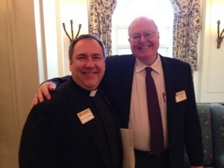  The President of the so-called *Catholic League.* Bill and his organisation tend to be on the Tea Party side of Conservative politics and on the very far lay clericalist end of the Catholic spectrum. Donohue is a major promoter of denialism in the CSA disaster, if anything blaming a cabal of rogue homosexual clergy of abusing children. He infamously brands ‘victims’ ‘repressed memory’ frauds and ‘gold diggers.’

[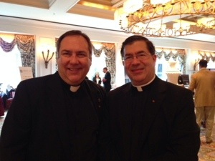](http://wdtprs.com/blog/wp-content/uploads/2014/02/20140208-113902.jpg) *With Fr Pavone of Priests for Life.*

*In late 2011, Pavone was directed by his bishop, Patrick Zurek, to return to the Amarillo diocese and assume normal parochial responsibilities. Pavone and his companions were running a virtual corporation, lost is tax exemption after the IRS audit the operation. Priests for Life, worthy and noble cause that it espouses, was acting like a church with the Church.* "There can be loyal opposition. That is how the church grows"- Pavone. *No wonder Zuhlsdorf warms to this lot.*

*I had a good chat with Sen. Santorum, who was the speaker last night.*

This is as close as Zuhlsdorf gets to the Presidency. Santorum was a drop out from the Republican nomination race in 2012. He is also a high profile promoter of *Intelligent Design*.

[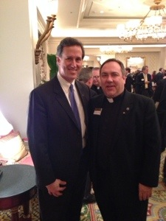](http://wdtprs.com/blog/wp-content/uploads/2014/02/20140208-081206.jpg)

Rick’s excuse for a terrible misfortune:

*"Every year more and more of them get married, and every year the relationship with my wife gets worse. "Unfortunately the homosexuals have ruined my marriage," he explained to reporter Bruce*

*"Ever since the Supreme Court struck down DOMA, we've been sleeping in separate rooms. It's like I don't even know who she is anymore. This is what the gays want: to destroy the* *institution of marriage. We won't be the last.”* - Santorum, July 2013 explaining his divorce.

*After supper I was pleased to meet up with one of the favorites of the Fishwrap,* (aka NCR) *Michael Novak.* (Novak, Weigel and others are leading Conservative Catholic lay ideologues. Zuhlsdorf relies heavily upon them to establish ‘authority’ for many of his assertions).

[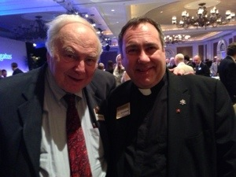](http://wdtprs.com/blog/wp-content/uploads/2014/02/20140208-081235.jpg)

Then there is more of the shameless Zuhlsdorf Inc entrepreneurial promotions:

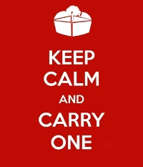

**Help support Fr. Z’s Gospel of Life work at no cost to you. Do you need a Real Estate Agent? Calling these people is the FIRST thing you should do!**

***A self-referencing ideologue***

Zuhlsdorf has been feeling the heat from Francis in word and dramatic act. Zuhlsdorf’s anger and resentment against the Pope are largely explainable by Francis simple lifestyle compared with the pampered existence of Zuhlsdorf. He is also highly critical of Francis consistent message on an evangelisation based on mercy, compassion and actual pastoral engagement. Zulhsdorf is shown up as being narrow-mindedly judgmental, rigidly legalistic, lacking in Christ like compassion and crassly materialistic in a most self-serving way. Zuhsldorf, facing his own huge credibility problem, deflects attention by undermining that of Pope Francis. (6)

*Fr John Zuhlsdorf, who hosts a popular conservative blog, wrote, “I wonder how many people are still listening to him seriously on this issue.”*

*Zuhlsdorf also questioned the Pope’s economic perspectives because he is from Argentina. “I don’t mean this to be snarky, though I realise it could come off that way, given Argentina's track record, should anyone from Argentina tell anyone else anything about how to deal with economic issues?”*

He hoists himself on his own petard. In *Evangelii Gaudium,* Francis exposes and describes the Zuhlsdorf character to a tee:

*This worldliness can be fuelled in two deeply interrelated ways. One is the attraction of gnosticism, a purely subjective faith whose only interest is a certain experience or a set of ideas and bits of information which are meant to console and enlighten, but which ultimately keep one imprisoned in his or her own thoughts and feelings. The other is the self-absorbed promethean neopelagianism of those who ultimately trust only in their own powers and feel superior to others because they observe certain rules or remain intransigently faithful to a particular Catholic style from the past. A supposed soundness of doctrine or discipline leads instead to a narcissistic and authoritarian elitism, whereby instead of evangelizing, one analyzes and classifies others, and instead of opening the door to grace, one exhausts his or her energies in inspecting and verifying. In neither case is one really concerned about Jesus Christ or others. These are manifestations of an anthropocentric immanentism. It is impossible to think that a genuine evangelizing thrust could emerge from these adulterated forms of Christianity. # 94* (7)

For Zuhlsdorf, Francis is more than just a nuisance and an inconvenience. He represents a very serious threat to the privilege, deference and patronage enjoyed by decadent elites. Their Clerical *sine-cure* self-referencing and self serving existence have been robustly condemned as Christ-less and totally counterproductive to his Gospel mission. Zuhlsdorf and cohort are finding fewer and fewer cities of refuge to receive them. They are hollow, rather dull and ignorant effeminate men of little depth who have nothing of substance to say.

***In the end, this is what it’s all about:---------***

**I am grateful for recent donations all during April and now, in May, from: *Zuhlsdorf is showing moderation and restraint this month. Usually it’s $5,000 on top of the pious goods store takings!***

SZ (monthly), NF (monthly), MF (monthly), DM (monthly), CK (monthly), TT (monthly), LM (monthly), AK (monthly), LC (monthly), MMcG (monthly), MJC (monthly), GC, LL (monthly), LC (monthly), BG, AM (monthly), SMcK-D (monthly), RL (monthly), DB (monthly), SAS!, HE!, GB (monthly), WMR (monthly), DN (monthly), JH (monthly), LS (monthly), CO'C (monthly), CB (monthly), TT (monthly), SC, DRF, WH, ST (monthly), NA (monthly), JG (monthly), ML (monthly), CB (monthly), SC!, JB (monthly), RMcE (monthly), DE (monthly), TR (monthly), DN (monthly), PL (monthly), NA x2 (monthly), TB (monthly), RPF (monthly), ES (monthly), KE (monthly), MC (monthly), BB (monthly), MK (monthly), AR (monthly), J-AF (monthly), CT (monthly), Fr. JB!!!, NL (monthly), JE (monthly), SC (monthly), JV (monthly), JB (monthly), LS (monthly), BC (monthly), KB (monthly), LLM (monthly), KM, GH (monthly), AN (monthly), AH (monthly), GC, WH, CAM, JFL (monthly), JP (monthly), AB (monthly), JL (monthly), RR (monthly), SB (monthly - $1/day!), LC (monthly), DH (monthly), MD (monthly), FV!, Fr. RH (monthly), BT (monthly), VW (monthly), GG (monthly), TK (monthly), SMcK-D x2 (monthly), JN (monthly), MZ (monthly), DM (monthly), SS (monthly), DS (monthly), WH (monthly), CG (monthly), EB (monthly), RR (monthly), AP (monthly), MR (monthly), MRS (monthly)  
  
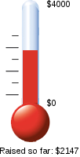  
  
To set up a *recurring, monthly donation* (even a small one) go to the bottom of this blog and look for the drop down menu! I remember benefactors in my prayers and during Mass. I remember benefactors in my prayers and periodically say Mass for your intention.

Top of Form

https://www.paypal.com/en_US/i/scr/pixel.gif

­­­­­­­­­­­­­­­­--------------------------------------------------------------------------------------------------------------------------------------

**Endnotes:**

1. Michael Sean Winters, “The Right blasts Francis (again)! *NCR* 12 May, 2014. Linked [here](http://ncronline.org/blogs/distinctly-catholic/right-blasts-francis-again).

(2) Michael Sean Winters, “US conservatives attack Francis over wealth redistribution**,”** *The Tablet* 12 May, 2014. Linked [here](http://www.thetablet.co.uk/news/778/0/us-conservatives-attack-francis-over-wealth-redistribution-comments-to-un-heads-)

(3) Zuhlsdorf’s tortured Midrash and apologia are linked [here](http://wdtprs.com/blog/2013/11/evangelii-gaudium-54-and-the-attack-on-trickle-down-economics/) and [here](http://wdtprs.com/blog/2013/11/evangelii-gaudium-54-trickle-down-economics-significant-translation-error-changed-meaning/)

(4) John Gehring, “It’s not just Pope Francis – God wants Wealth Distrubuted, Too,” *On Faith,* May 12, 2014. Linked [here](http://www.faithstreet.com/onfaith/2014/05/16/its-not-just-pope-francis-god-wants-wealth-redistributed-too/32101).

(5) A snap shot of Monahan, his business empire and his elitist group can be found [here](http://www.holysmoke.org/sdhok/dom02.htm).

(6) Even the conservative Patheos puts Zuhlsdorf under close scrutiny: Mark Shea, “Fr Z seems to (be) getting the knives out for Pope Francis.” Linked [here](http://www.patheos.com/blogs/markshea/2013/12/fr-z-seems-to-getting-the-knives-out-for-pope-francis.html). See also, Rod Dreher, “The Catholic Party vs The Catholic Church,” *The American Conservative,* May 8, 2014. Linked [here](http://www.theamericanconservative.com/dreher/catholic-party-church-pope/comment-page-1/)

(7) Zuhlsdorf venting about Francis’ categorization of Trads: “I am a Self- Absorbed Promethean Neopelagian” See Zuhlsdorf [here](http://wdtprs.com/blog/2013/12/new-z-swag-i-am-a-self-absorbed-promethean-neopelagian-and-proud-of-it/) and Sean Michael Winters, “Evagelii Gaudium: First Impressions,” *NCR* 26 November, 2014. Linked [here](http://ncronline.org/blogs/distinctly-catholic/evangelii-gaudium-first-impressions)

___________________________________________________________________________

In Part III, there will be more on the shameless way Zuhlsdorf plays the Traditionalist/Conservative game of manipulating the psychologiacal and spiritual fragility of the guilt-ridden, the scrupulous and the easily led. His ruses of choice are to peddle rubric fetishes, arcane legalisms, meaningless, second hand ecclesiastical Latinisms all in order grow his business and to mask his real interests: his own prosperity and self-indulgent life style.

David Timbs writes from Melbourne, Victoria, Australia.

25/05/14